Algorithm for file updates in Python

Project description
Within my organization, access to restricted content is managed through an approved list of authorized IP addresses stored in a file called allow_list.txt. A secondary remove list is maintained to identify IP addresses that have been flagged for removal and should no longer be permitted access to the restricted content. To streamline this process, I developed a Python algorithm that automatically updates the allow_list.txt file by identifying and removing any IP addresses that appear on the remove list. This eliminates the need for manual updates and ensures access controls remain current and accurate.

Open the file that contains the allow list
To initiate the algorithm, the file name allow_list.txt was stored as a string in a variable named import_file in preparation for opening and processing the file:

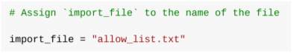

The file was then opened using a with statement, which automatically handles closing the file once the operation is complete:

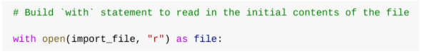

To read the allow list file, my algorithm uses the with statement with the .open() function in read mode to access IP addresses stored in the allow list file. To help manage the resources, the with keyword closes the file after exiting the with statement. The code, open(import_file, "r") as file: has two parameters. The two parameters identify the file to import and specify what I want to do with it, respectively. The “r” shows that I want to read it. The as keyword assigns the result of the .open() function to a variable called file making the file contents accessible for use within the with statement.

Read the file contents
I used .read() to convert the file contents into the string.

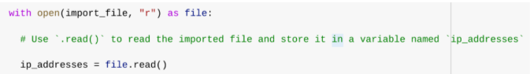

I used the ,open() function with the argument “r” for “read” to call the .read() function in the body of the with statement. Using .read() allowed me to convert the file into a string so that it's readable. Then, I used the .read() method to the file variable seen in the with statement. Lastly, I assigned the string output to the variable ip_addresses.

This code reads the allow_list.txt file and stores its contents as a string, making the IP address data accessible for further processing and manipulation later in the program.

Convert the string into a list
I needed the allow list in list format so I could remove IP addresses. To do this, I used .split() to convert the ip_addresses string into a list:

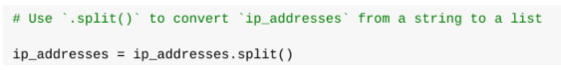

The .split() function is called on the ip_addresses variable to convert the string of whitespace-separated IP addresses into a list of individual elements. This makes it easier to locate and remove specific IP addresses from the allow list. The resulting list is then stored back into the ip_addresses variable for use in the next steps of the algorithm.

Iterate through the remove list
I used a for loop to iterate through the IP addresses that are elements in the remove_list.

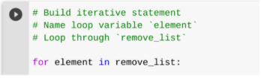

The for loop iterates over the ip_addresses list, applying the same code to each element. The for keyword begins the loop, followed by the loop variable element and the keyword in which directs Python to assign each IP address in the list to the variable element one at a time for processing.

Remove IP addresses that are on the remove list
The algorithm identifies any IP address that exists in both the ip_addresses allow list and the remove_list and removes it accordingly. As there were no duplicate IP addresses present in the allow list the following code was used to accomplish this:

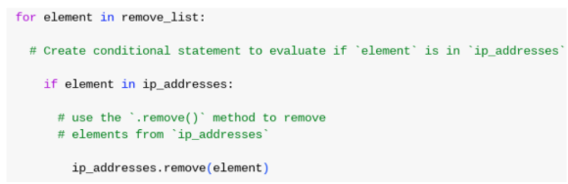

A conditional statement was included within the for loop to first verify that each element existed in the ip_addresses list before attempting removal. This prevented potential errors that would occur if the .remove() method was applied to a value not present in the list. When the condition was confirmed as True the .remove() method was called on ip_addresses with element passed as the argument to delete the matching IP address from the allow list.

Update the file with the revised list of IP addresses
As the final step of the algorithm, the updated ip_addresses list needed to be written back to the allow_list.txt file. Since the data was in list format, it first needed to be converted back into a string using the .join() method before the file could be updated, as shown in the following code:
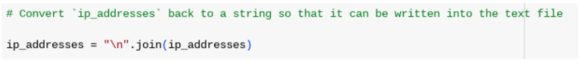

The .join() method was used to combine all elements of the ip_addresses list into a single string with the newline character \n as the separator, ensuring each IP address appeared on a separate line in the output. This converted string was then passed as an argument to the .write() method within a new with statement to overwrite the allow_list.txt file with the updated list of authorized IP addresses:

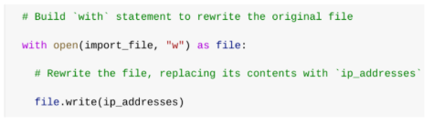
The open() function was used with the “w” argument to open the allow_list.txt file in write mode, allowing its existing contents to be overwritten. The .write() method was then appended to the file object and called with ip_addresses as the argument to replace the previous file contents with the updated list of authorized IP addresses. This ensured that all removed IP addresses were permanently revoked from accessing the restricted content.

Summary
The algorithm automates the removal of flagged IP addresses from the allow_list.txt file by opening the file and converting its contents into a list stored in the ip_addresses variable. A for loop then iterates through the remove_list and uses a conditional statement combined with the .remove() method to delete any matching IP addresses from ip_addresses. Finally the updated list is converted back into a string using the .join() method and written back to the allow_list.txt file to ensure all revoked IP addresses are permanently removed from the authorized access list.

Activity Overview
In this activity, you will create a new portfolio document to demonstrate your experience using Python to develop algorithms that involve opening files and parsing their contents. You can add this document to your cybersecurity portfolio, which you can share with prospective employers or recruiters. To review the importance of building a professional portfolio and options for creating your portfolio, read Create a cybersecurity portfolio.
To create your portfolio document, you will review a scenario and follow a series of steps. This scenario is connected to the Create another algorithm lab that you have just completed. You will explain the code you developed in that lab, and this will help you prepare for future job interviews and other steps in the hiring process.
Be sure to complete this activity before moving on. The next course item will provide you with a completed exemplar to compare to your own work.

Scenario
Review the following scenario. Then complete the step-by-step instructions.
You are a security professional working at a health care company. As part of your job, you're required to regularly update a file that identifies the employees who can access restricted content. The contents of the file are based on who is working with personal patient records. Employees are restricted access based on their IP address. There is an allow list for IP addresses permitted to sign into the restricted subnetwork. There's also a remove list that identifies which employees you must remove from this allow list.
Your task is to create an algorithm that uses Python code to check whether the allow list contains any IP addresses identified on the remove list. If so, you should remove those IP addresses from the file containing the allow list.
Note: This scenario involves developing the same algorithm that is developed in Tasks 2-7 of the Create another algorithm lab. (You do not need to reference Task 1 and Tasks 8-10 of the lab to complete this portfolio activity.) You should revisit the lab to get screenshots to include in your portfolio document.

Step-By-Step Instructions
Follow the instructions to complete each step of the activity. Then, answer the 9 questions at the end of the activity before going to the next course item to compare your work to a completed exemplar.

Step 1: Access the template
To use the template for this course item, click the link and select Use Template. (In this step, you will just open the template. More instructions for how to use the template will be included in later steps.)
Link to template: Algorithm for file updates in Python
OR
If you don’t have a Google account, you can download the template directly from the following attachment.
The following supporting material will help you complete this activity. The document Instructions for including Python code provides instructions and best practices for including samples of Python code in your portfolio activity. Keep it open as you proceed to the next steps.
To use the supporting material for this course item, click the link and select Use Template.
Link to supporting material: Instructions for including Python code
OR
If you don’t have a Google account, you can download the supporting material directly from the following attachment.
The file that you want to open is called "allow_list.txt". Assign a string containing this file name to the import_file variable. Then, use a with statement to open it. Use the variable file to store the file while you work with it inside the with statement.
Describe the Python syntax, functions, and keywords you need to accomplish this in the Open the file that contains the allow list section of the Algorithm for file updates in Python template. In the Task 2 section of Create another algorithm lab, take a screenshot of this portion of your code. Or, type this code directly into the template.
Next, use the .read() method to convert the contents of the allow list file into a string so that you can read them. Store this string in a variable called ip_addresses.
Describe the Python syntax, functions, and keywords you need to accomplish this in the Read the file contents section of the Algorithm for file updates in Python template. In the Task 3 section of the Create another algorithm lab, take a screenshot of this portion of your code. Or, type this code directly into the template.
In order to remove individual IP addresses from the allow list, the IP addresses need to be in a list format. Therefore, use the .split() method to convert the ip_addresses string into a list.
Describe the Python syntax, functions, and keywords you need to accomplish this in the Convert the string into a list section of the Algorithm for file updates in Python template. In the Task 4 section of the Create another algorithm lab, take a screenshot of this portion of your code. Or, type this code directly into the template.
A second list called remove_list contains all of the IP addresses that should be removed from the ip_addresses list. Set up the header of a for loop that will iterate through the remove_list. Use element as the loop variable.
Describe the Python syntax, functions, and keywords you need to accomplish this in the Iterate through the remove list section of the Algorithm for file updates in Python template. In the Task 5 section of the Create another algorithm lab, take a screenshot of this portion of your code. Or, type this code directly into the template.
In the body of your iterative statement, add code that will remove all the IP addresses from the allow list that are also on the remove list. First, create a conditional that evaluates if the loop variable element is part of the ip_addresses list. Then, within that conditional, apply the .remove() method to the ip_addresses list and remove the IP addresses identified in the loop variable element.
Describe the Python syntax, functions, and keywords you need to accomplish this in the Remove IP addresses that are on the remove list section of the Algorithm for file updates in Python template. In the Task 6 section of the Create another algorithm lab, take a screenshot of this portion of your code. Or, type this code directly into the template.
In addition, include a sentence that explains that applying the .remove() method in this way is possible because there are no duplicates in the ip_addresses list.
Now that you have removed these IP addresses from the ip_address variable, you can complete the algorithm by updating the file with this revised list. To do this, you must first convert the ip_addresses list back into a string using the .join() method. Apply .join() to the string "\n" in order to separate the elements in the file by placing them on a new line.
Then, use another with statement and the .write() method to write over the file assigned to the import_file variable.
Describe the Python syntax, functions, and keywords you need to accomplish this in the Update the file with the revised list of IP addresses section of the Algorithm for file updates in Python template. In the Task 7 section of the Create another algorithm lab, take a screenshot of this portion of your code. Or, type this code directly into the template.
To finalize the document and make its purpose clear to potential employers, be sure to complete the Project description and Summary sections of the Algorithm for file updates in Python template.
In the Project description section, give a general overview of the scenario and what you accomplished in Python. Write three to five sentences.
In the Summary section, provide a short summary of the algorithm by highlighting its main components. Write four to six sentences.

